Spring Security

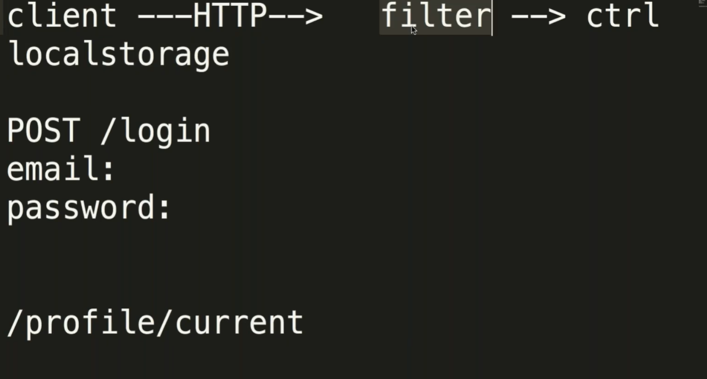

Testing

Test the service layer, controller (Unit testing)

Mockmvc for controller